**Leader Overview**

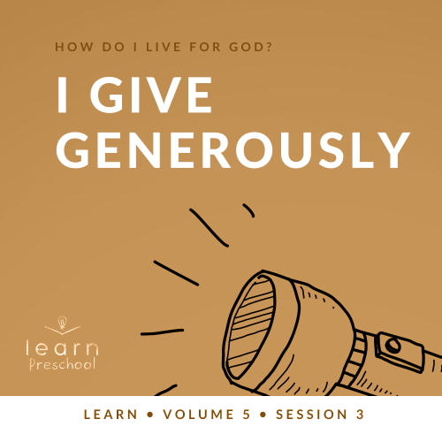

**Volume Overview**

**How do I live for God?**

*As we learn how to live for God, we’ll explore what that looks like in our everyday life. We know the Bible speaks to us, and God wants each of us to live connected to other believers. So, if that’s all true, how do we put God first? How do we get through all the confusion and uncertainty in this world? What does God expect when it comes to giving? How can we show others we care? In these sessions, we’ll consider what the Bible has to say in response to very important questions like these*.

**Session Overview**

**I Give Generously**

*In this* **Learn** *session, preschoolers discover what it means to give. Numerous times throughout the New Testament, Jesus taught the importance of giving. As Christians, we are called to give and to take care of others. Preschoolers will learn that God blesses those who give*.

**Bible Lesson**

A Widow’s Offering

[Mark 12:41–44](https://ref.ly/logosref/Bible.Mk12.41-44)

**Faith Fact**

I give generously.

**Faith Verse**

[Matthew 6:33](https://ref.ly/logosref/Bible.Mt6.33)

“Seek the Kingdom of God above all else, and live righteously, and he will give you everything you need.”

**Preparing for the Session**

**Leader Preparation Time: 20–25 Minutes**

|  |
| --- |
| ***You Will Need***  ***Preservice Activities***  *• Money or coins (real or toy/fake)*  *• Offering container*  *• Snacks to share*  ***Large Group***  *• Bible*  *• Worship songs (Song suggestions: “What a Mighty God We Serve” by Listener Kids; “Brave” by Saddleback Kids; “No Fear in Love” by Elevation Church Kids)*  *• For groups not using a phone or tablet only, add:*  *• Projector or TV*  *• Laptop*  *•* ***Countdown60 Video****–60 seconds*  *•* ***Faith Fact Sound*** *video (bell ringing)*  *•* ***Faith Fact Slide***  *•* ***Faith Verse Slide***  *•* ***Bible Lesson Video A***  *•* ***Bible Lesson Video B***  ***Small Group***  *• Variety of coins*  *• Paper*  *• Crayons or colored pencils*  *• Optional: Let kids use the back of the* ***Small Group Activity Page****.*  *•* ***Small Group Activity Page****, one per kid*  *• Crayons*  *• Painter’s tape*  *• Small balls (table tennis or ball pit size) or balled-up pieces of paper*  *• Container to hold balls or paper wads*  *•* ***Countdown60 Video****–60 seconds*  *• Two bananas or other fruit or snack*  *To access session content and videos from a computer, visit:* [*BibleEngagementProject.com/downloads*](https://bibleengagementproject.com/downloads) |
| ***Getting Ready***  ***Preservice Activities***  *• Set out toys and snacks.*  ***Large Group***  *• Download videos and slides if needed.*  *• Select worship song(s) and have them ready to play.*  ***Small Group***  *• Print copies of the* ***Small Group Activity Page****, one per kid.*  *• Tape a line down the middle of the playing area.*  *First time leading* Learn *for Preschool? Check out the* [Facilitator Guide](https://0b769b0ed3569ef9d18b-f88d8272f61086866d50d048b43ef630.ssl.cf2.rackcdn.com/sites/biblengagementproject/Listen_Facilitator_Guide.pdf). |

**Preservice Activities**

*See what’s needed at the beginning of the session.*

**Bible Story Warm-Up Activity**

*As kids are coming in, hand them coins and have them sit in a circle*.

Today, we’ll learn what it means to be generous. Does anybody know what the word *generous* means? *(Allow responses.)* Those are all great guesses. Being generous means we share what we have to help others when they have a need. It also could mean we take what we have and give it away. When we’re generous, we think more about others than about ourself.

• *Hold up the offering container*.

Today’s Bible story tells us about people who give money in the offering, so we’re going to take an offering now. You have some money that I gave you when you came in. You’ll decide how much of your money that you want to give. You don’t have to give any money if you don’t want to. You can give part of your money or all of your money. When I call your name, put your money in the offering container.

• *Allow the kids to give their money if they choose to*.

• *When they’re finished, ask the following questions:*

Was it hard to decide how much money to give?

Why can it be hard to give away the money?

Raise your hand if you decided to give all your money. *(Group response)*

Giving part of your money is generous and giving all your money is very generous. God wants us to give with a happy heart. I know that choosing to give generously isn’t always easy, but God loves a cheerful giver.

**Snack**

**Snacks to Share**

Today, we’re going to practice being generous givers. I’d like someone to help me give the snack to the rest of you.

• *Choose someone to hand out the snack*.

Isn’t it fun to share with others? *(Group response)* When people are generous, they often give things away. Sometimes people are generous to you. Maybe they gave you a nice birthday present or surprised you with something special for no reason.

How do you feel when someone gives you something?

What is one thing you could share with others?

What’s the hardest thing for you to share?

I’m so excited to learn more about generous giving today with you.

**Free Play**

*Any extra time can be spent playing with toys*.

**Transition**

*A few minutes before service begins have kids make their way to the large group area and sit in their designated areas*.

**Large Group**

**25 Minutes**

*See what’s needed at the beginning of the session*.

**Introduction**

Hi, friends! Who is excited to be here? *(Group response)* Today, we’ll learn about giving. One way we can show God we love Him is by giving. There are so many different ways we can give. Who thinks you know one way to give? *(Allow responses.)* Those are all great ways to give.

Today, we’ll learn that God wants us to be a generous and cheerful giver. He wants the real reason we give to be because we know everything good comes from Him. Being a generous giver isn’t about how big or expensive the gift is. It’s about giving from your heart. We can all be generous and happy to give.

**Faith Fact**

That’s my favorite part about this whole thing is that we all can be generous. It doesn’t matter what you look like—if you’re a boy or a girl, if you’re short or tall, if you have red hair or brown hair, or if you have glasses or freckles. Everyone can be generous. That reminds me of today’s Faith Fact: **I give generously**.

• *Show the* ***Faith Fact Slide***.



Put your hands together like you’re holding something. When we say our Faith Fact, we’re going to pretend to throw it in the air like we’re giving it to God. Ready? **I give generously.** *(Throw hands in air.)* Amazing! This time let’s pretend to throw it to someone else like we’re giving something to our friends. Ready? *(Toss hands toward someone.)* **I give generously**.

**Bible Time**

One of the best ways to learn how to live is to read God’s Word. The Bible teaches us what to do, how to act, and how to love our friends. I’m so glad God gave us this awesome book. *(Hold up the Bible.)* I’m also really glad that we don’t have to learn alone. Let’s see what Lizzy and Grandpa have to teach us today about giving generously.

• *Play* ***Bible Lesson Video A***.

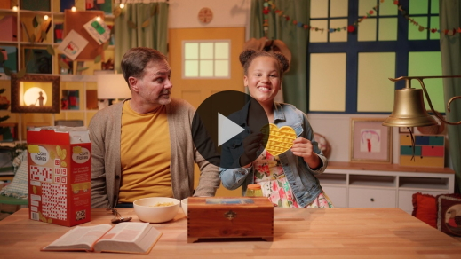

Wow! You did awesome! Way to work together to help Lizzy solve all the clues today. Who enjoyed today’s Bible story? *(Group response)* It was so amazing to hear about a woman with so little who gave so much. Who did Jesus say gave more, the rich people or the poor woman? *(Allow responses.)* That’s right! The woman gave more because she gave all she had. Jesus wanted everyone to know that it’s okay to give a little if you only have a little. If you have a lot, you can give a lot. God wants us to be happy to give whatever we can.

**Worship**

When we give, it’s not just about money. We can give our time, our things, and our attention. Have you ever had someone tell you to pay attention? *(Group response)* Have you ever tried to talk to someone who wasn’t really paying attention to you? *(Group response)* One of the best ways that we can give our attention is to focus on God. When we worship, that’s what we’re doing. When we cheerfully focus on God, we’re generously giving Him more attention. When we worship today, let’s be sure to be cheerful worshippers.

**Praise**

Are you ready to worship God today? Show me your biggest smile! *(Group response)*

Are you glad God made you? Twirl around and say, “Thank You, God!” *(Group response)*

Are you ready to sing? Clap your hands. *(Group response)*

**Sing**

Let’s sing and focus our heart and mind on God. When we focus on Him and remember that everything comes from Him, it makes being generous a whole lot easier.

• *Lead the kids in singing one or two songs. See song suggestions at the beginning of the session*.

**Prayer**

Wow! You always do such a good job of singing and worshipping. I love hearing you tell God how much you love Him and singing about how great He is. Let’s pause and pray before we move on.

|  |
| --- |
| Dear God, thank You for everything You have given to me. Help me to remember that everything comes from You. When I give, I want to be generous. I want to be a cheerful giver. Please help me, God. Amen. |

**Bible Time cont’d**

It’s time to check back in with Lizzy. Do you think she’ll help us practice the Faith Verse? *(Group response)*

• *Play* ***Bible Lesson Video B***.

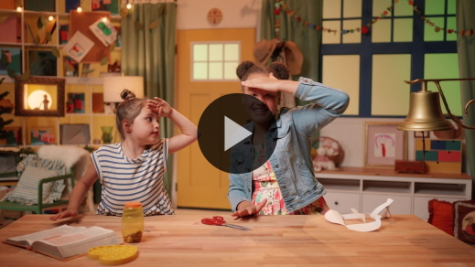

You’re doing a great job of learning our Faith Verse. This verse helps us remember to focus on God. When we focus on God, we remember that everything comes from Him. Our Faith Verse reminds us that when we seek God first, He takes care of us. That’s why we’re learning this verse together.

**Response Time**

• *Play a worship song quietly*.

We’ve learned about giving and being generous, but sometimes being generous isn’t that easy. In our Bible story, who gave the best offering? *(Allow responses.)* Yes, it was the widow. Jesus told the disciples that the woman had given more because she gave everything she had. The other people were giving a lot of money, but they still had more money at home.

Jesus was pointing out to the disciples that it wasn’t just the size of the gift that mattered, but what their sacrifice meant. Does anybody know what the word *sacrifice* means? *(Allow responses.)* When we sacrifice that means we give something up that’s hard for us. In the Bible story, the widow gave a sacrifice because she gave all the money she had. God blesses people who are generous. Let’s respond to what we’ve learned today. As we pray, I want you to ask God to help you to be generous.

• *Optional: Have the kids repeat phrases of the prayer after you*.

|  |
| --- |
| Dear God, thank You for teaching us how to give to others. Help us to be happy as we give and share. Amen. |

**Faith Verse**

Did you know that it makes God really happy when we learn the words that are in the Bible? Let’s practice our Faith Verse together.

• *Show the* ***Faith Verse Slide***.

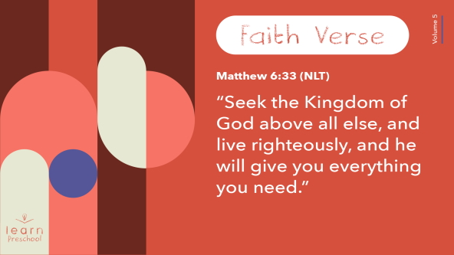

[Matthew 6:33](https://ref.ly/logosref/Bible.Mt6.33) (NLT)

“Seek the Kingdom of God above all else, and live righteously, and he will give you everything you need.”

**Matthew** *(hands at waist, spread apart, palms up and out)*

**6**: *(hands together like a clap)*

**33** *(hands opened to “book”)*

**“Seek the Kingdom of God** *(one hand at brow, “search” left and right)*

**above all else**, *(point up with both index fingers)*

**and live righteously**, *(clasp hands in prayer waist-high)*

**and he will give you** *(open hands flat at waist)*

**everything you need.”** *(move hands out to side and then clap)*

That is so great! Kids, you’re doing a fantastic job learning your Faith Verse.

**Closing**

We’ve learned so much today. Who can tell me one thing you’ve learned? *(Allow responses.)* That’s wonderful! I love that we can come together and learn more about God and His Word.

• *Play the* ***Faith Fact Sound*** *video (bell ringing)*.

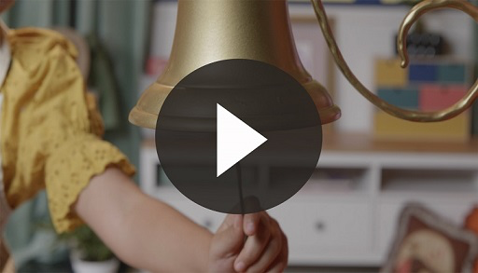

I love that sound! It means that we get to practice our Faith Fact one more time.

• *Show the* ***Faith Fact Slide***.



Let’s shout it together. Ready? **I give generously.** Now, we’ll say it as quietly as we can. Reach down low *(bend down low)* and whisper it. **I give generously.** Now, jump up high and shout it. **I give generously**.

**Dismissal to Small Groups**

Way to go! Now, let’s go see what fun is waiting for us in our small groups circle time.

• *Dismiss the kids by groups*.

|  |
| --- |
| ***Leader Tip:*** *This can be done by assigning color teams or by age groups. Note that some young preschoolers may not know their age. Using a colored sticker, jersey, or wristband will help separate the kids and help identify their small groups.* |

**Small Group**

**25 Minutes**

*See supplies and prep instructions at beginning of session or in each activity below.*

|  |
| --- |
| ***Leader Tip****: Small groups can alternate to each circle, or all groups can do each activity at the same time. If you choose to alternate, you will need at least one leader per circle.* |

**Circle 1**

**Group Connection**

**Coin Rubbing**

|  |
| --- |
| ***You Will Need***  *• Variety of coins*  *• Paper*  *• Crayons or colored pencils*  *• Optional: Let kids use the back of the* ***Small Group Activity Page****.*  *No prep needed for this activity.* |

Our Bible story today was about people giving their offering. Some people gave a lot of money, and one person gave a little.

• *Show kids the coins*.

What do you remember about the widow and her offering? *(Allow responses.)* Jesus said her offering was the most generous even though she only gave two coins. You’re going to choose two coins to represent her offering. Then, you will make rubbings of those coins.

• *Provide kids with two coins and crayons*.

• *Use paper or the back of the* ***Small Group******Activity Page***.

• *Tip: It may help younger children if you tape the coin in place on the table to hold it steady while they make the rubbing*.

• *Leaders may need to demonstrate how to do the coin rubbing*.

Sometimes God will direct us to give something we have to someone who may need it. Just like the woman who generously gave two coins, our two coins remind us that we are to help people in need.

• *During the activity, interrupt and practice the Faith Fact:* **I give generously**.

• *Play the* ***Faith Fact Sound*** *video. Review the Faith Fact even if you can’t play the sound*.



**Circle 2**

**Activity Page Time**

**Seek and Find**

|  |
| --- |
| ***You Will Need***  *•* ***Small Group Activity Page****, one per kid*  *• Crayons*  ***Getting Ready***  *• Print copies of the* ***Small Group Activity Page****, one per kid.* |

We’ve been spending time learning our Faith Verse. Let’s say it together. Ready?

[Matthew 6:33](https://ref.ly/logosref/Bible.Mt6.33) (NLT)

“Seek the Kingdom of God above all else, and live righteously, and he will give you everything you need.”

This verse tells us to seek. When we seek something, that means we’re looking for it. It’s the one thing we want to find. On our ***Small Group Activity Page*** today, you’ll see a woman giving an offering. There are five coins hidden in the picture. Every time you find one, color it or circle it with your crayon.

• *Give each kid an* ***Small Group Activity Page*** *and crayons*.

• *Help kids find the coins if needed*.

Wow! You’re great seekers. Are you happy that you found the coins? *(Allow responses.)* When we seek God first, He will take care of us. This woman who willingly gave everything to God shows us how to trust in Him when we give generously. Let’s say our verse one more time.

[Matthew 6:33](https://ref.ly/logosref/Bible.Mt6.33) (NLT)

“Seek the Kingdom of God above all else, and live righteously, and he will give you everything you need.”

Great job!

**Circle 3**

**Feet-to-Floor Game Time**

**Give It Away**

|  |
| --- |
| ***You Will Need***  *• Painter’s tape*  *• Small balls (table tennis or ball pit size) or balled-up pieces of paper*  *• Container to hold balls or paper wads*  *•* ***Countdown60 Video****–60 seconds*  ***Getting Ready***  *• Tape a line down the middle of the playing area.* |

Wow! We’ve had so much fun today learning about being generous. Can you say today’s Faith Fact with me? **I give generously.** Awesome! Sometimes God will direct us to give something we have to someone who needs it. Today, we have a game that will help us give things to others.

We’re going to have two teams today. We’ll see who can give away all these things.

• *Hold up the container with balls and then place the balls along the taped line*.

• *Form two teams*.

• *Place one team on each side of the taped line*.

When I say, “Go,” you’ll give away as many of the balls as you can to the other team before time runs out. When time’s up, the winning team will be the one with the fewest balls on their side of the line. If your team gets rid of all the balls before time’s up, you win!

• *Play the* ***Countdown60 Video*** *timer*.

• *Determine the winner*.

That was amazing! You all played so hard. Let’s give a big hand to the winning team. Great job!

**Circle 4**

**Hands-On Learning**

**No Leftovers!**

|  |
| --- |
| ***You Will Need***  *• Two bananas or other fruit or snack*  *No prep needed for this activity.* |

Our Faith Verse tells us that we should seek God first. What does it mean if someone or something is first? *(Allow responses.)* Those are great answers! When we put someone or something first, we honor that person or thing the most. Think about all your toys. Raise your hand if you like one toy more than all the others. *(Group response)* How do other people know that it’s your favorite toy? *(Allow responses.)* When something is our favorite, we probably keep it right with us. We’d be very sad if we lost it or something bad happened to it.

• *Tell a personal story about a favorite toy if you have one*.

When we put something or someone first, we think about it more than anything else. Our Faith Verse says that God should be that important to us. I’ll use this banana to show you what that looks like.

• *Hold up a whole banana*.

When we seek God first, we give our best to Him. Imagine I want to share this banana with God. If He gets the best part of my banana, what would I give to Him? *(Allow responses.)* He should get the whole banana. It’s perfect! No one has taken any bites out of it.

• *Pick up the second banana*.

• *Peel the banana and take bites as you read each example, but leave a part of the banana for the end*.

Here’s what it might be like if I don’t put God first. When I put other things before talking to God, it’s like taking a bite out of the banana. *(Take a bite.)* If I go to the store and buy something fun before I give an offering that I know I should, God isn’t first. *(Take another bite.)* Then, I go out and play, but I still haven’t really talked with God. *(Take another bite.)* Now, look at my banana. *(Hold up partly eaten banana.)* If I give this to God, am I giving Him my best? *(Group response)*

Our Faith Verse says we should seek God first. Would I be putting God first if I gave Him this banana? *(Group response)* No, I wouldn’t. I need to give God my best. He has given us everything. That’s why we should seek God first. Let’s say our Faith Verse together.

[Matthew 6:33](https://ref.ly/logosref/Bible.Mt6.33) (NLT)

“Seek the Kingdom of God above all else, and live righteously, and he will give you everything you need.”

Great job! As you go through this week, remember to seek God first. When we seek Him first, it will be so much easier to give generously.

**Dismissal**

• *Play the* ***Faith Fact Sound*** *video (bell ringing)*.



• *Show the* ***Faith Fact Slide***.



Before we go, I want us all to shout our Faith Fact one more time. Ready? **I give generously.** Great job! I had so much fun learning about God from His Word with you. I can’t wait until next time.

• *Send home the* ***Small Group Activity Page*** *and coin rubbings with each kid*.

• *Remind parents that there are* ***Family Devotions*** *available on the app to do with their kid*.

• *Tell everyone the date and time for the next session*.